**BÁO CÁO OOP LAB 05**

**Họ tên: Trương Ngọc Mai – 20225879**

1. **Answer Question:**

Answet.txt (github)

1. **Source code:**

* AWTAccumulator.java

* SwingAccumulator.java

* *NumberGrid.java*

* *Javafx*
* *Painter.fxml*
* *PainterController*

* *Painter.java*

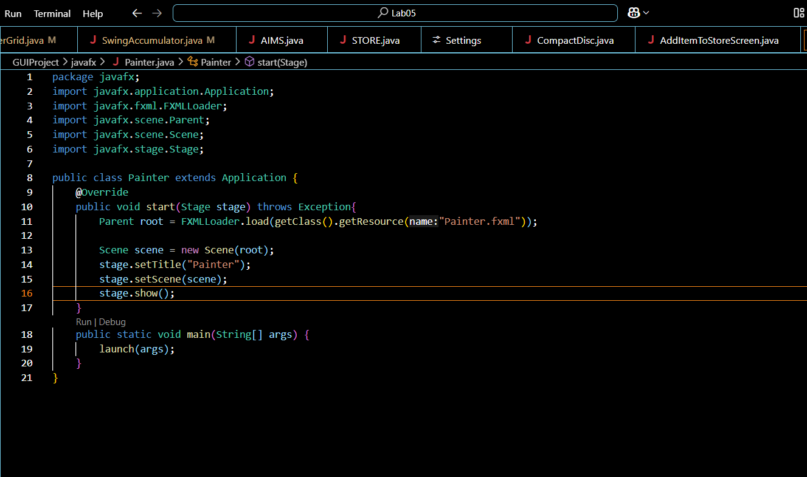

* *Screen*

*=>CartScreenController*

*=> StoreScreen1*

*=> MediaStore.java*

*=> cart.fxml*

*=> addBookStoreScreen*

*=>addCompactDisc*

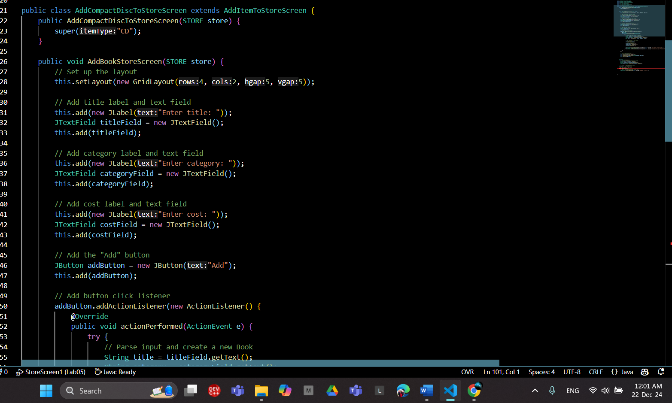

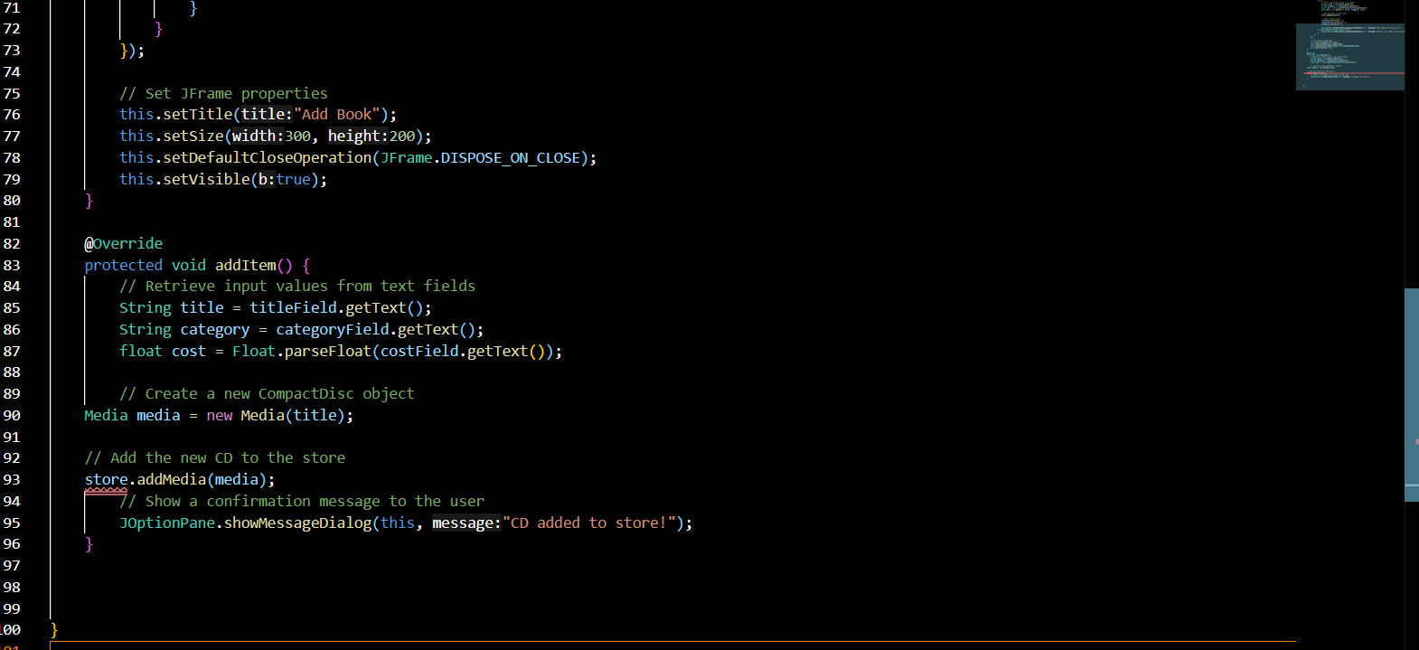

*=>addDigitalVdDisc*

*=>addItemToStoreScreen*

* *Exception*

*Play() in Playable*

*Play() In CompactDisc*

1. **Usecase Diagram and Class Diagram**

* **Usecase Diagram**

* **Class Diagram**

